BRAILLE-BRIDGE
A Low-Cost Bilingual Braille Writing System
Research paper: the problem, the device, and why it matters for blind and visually impaired students worldwide, with Bangladesh as a first case study.
Document | Research paper, version 1.0, October 2026
Author | Samin Yeasar
Email | samin@mentormind.bd
Portfolio | solez.html-5.me
GitHub | github.com/Solez-ai/braille.bridge
Official website | braile-bridge.vercel.app
Documentation | braille.mintlify.site
Project status | Prototype in active development

1. Abstract
In brief
BrailleBridge is a low-cost digital Braille writing system that works in English and a second language, currently Bangla. A blind or visually impaired student types on six mechanical dot keys. An ESP32 microcontroller translates each chord into text in real time. The device sends the chord codes over Bluetooth to a browser-based Teacher Software, which decodes them and shows the sighted teacher ordinary readable text. Several BrailleBridges can connect to one teacher at the same time; the student writes, and the teacher reads.
The prototype costs about US$12 in parts. This paper explains the problem the device addresses, how it works, what it could change in a first deployment in Bangladesh, why it matters well beyond it, and why existing alternatives, including those used in wealthy countries, still leave the core gap open.

BrailleBridge at a glance
Item | Specification
Input | Six Braille dot keys plus Space and Shift (Outemu Red mechanical switches)
Processor | ESP32 Dev Module with built-in Bluetooth and USB serial
Chord detection | 180 ms window; keys pressed within it become one chord
Languages | English (Grade 1 Braille) and Bangla, a second language from the Bharati Braille family used across South Asia; switched in software
Link to the teacher | Chord codes sent over Bluetooth; USB serial also available
Many students, one teacher | Several BrailleBridges can connect to one Teacher Software session
Teacher Software | Runs in the browser; nothing to install
Prototype parts cost | About US$12
Licence and stage | Apache License 2.0; prototype in development
Source: the BrailleBridge repository, documentation and project website [8].

2. The problem: silent answers are still answers
In many classrooms and examination halls, a blind student cannot independently produce an answer sheet that a sighted teacher can read. The usual workaround is to dictate every answer to a sighted writer, called a scribe. That arrangement solves one problem and creates several more:
- Privacy is lost. Answers must be spoken aloud, so nothing the student writes stays confidential.
- Independence is lost. Someone else controls the final written record and decides how it is interpreted.
- Speed is no longer the student's own. The student waits, repeats and slows down to the writer's pace.
- Transcription errors creep in. Technical terms, names and non-English phonetics are easily misheard or misspelled.
- The teacher cannot check the work directly. Embossed Braille is unreadable to most sighted teachers, so marking depends on an intermediary.
- Hardware is expensive. Mechanical braillers and digital Braille devices cost hundreds to thousands of dollars and are hard to repair close to where they are used.
Traditional Braille keeps the writing method the student knows but does not reach the teacher. Dictation reaches the teacher but removes the student from the act of writing. BrailleBridge is designed to close that gap without giving up Braille.

3. The solution: the student writes, the teacher reads
BrailleBridge is a complete classroom system with three parts: a six-dot Braille keyboard, an ESP32 translator, and a web-based Teacher Software. The student never needs a screen: each chord travels to the teacher, who sees it as readable text. Many BrailleBridges can report to one teacher.
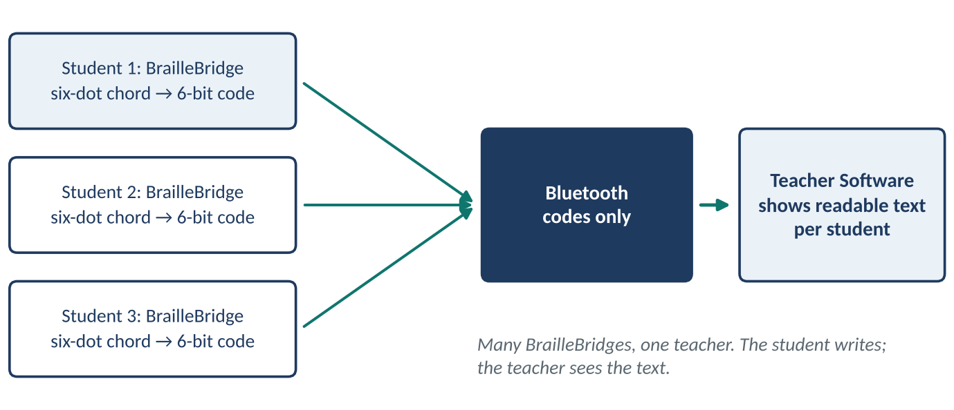
Figure 1. Several BrailleBridges send their codes by Bluetooth; the teacher sees the text.

How a character travels
- Press. The student presses a familiar six-dot chord on tactile mechanical keys. Dots are numbered 1 to 3 down the left column and 4 to 6 down the right.
- Translate. The ESP32 collects every key pressed within 180 ms, encodes them as a 6-bit value, and looks that value up in the active dictionary, English or Bangla.
- Send. The code travels over Bluetooth to the Teacher Software. Each student's BrailleBridge appears as its own feed.
- Read. The teacher sees ordinary text. The software displays, timestamps and saves every answer, and in exam mode shows all students side by side.

What is different
Each ingredient exists elsewhere: Braille keyboards, translation software, Bluetooth keyboards. To our knowledge the contribution is combining them in one affordable, repairable system built for classrooms and exams, with a second language, Bangla, built in as a first-class language:
- Real Braille input. Six tactile keys keep Braille as the student's natural writing method.
- Two languages, same keys. One device holds two dictionaries. Holding dots 4, 5 and 6 for half a second switches language; no hardware toggle is needed.
- A Shift layer. Shift adds capital letters, numbers, punctuation and maths symbols, and turns Bangla vowels into vowel signs, without extra keys. Tapping Shift alone deletes the last character.
- A dictionary-driven design. A new language is a new table of entries, not new program logic.
- Repairable by design. Switches, controller, enclosure and software can each be replaced separately for a few dollars.

4. How it helps
The benefits differ by who is in the room. In each case the starting point is the same: the student writes, and the answer is already text.
- Students. Write answers privately, at their own speed, in the method they already use, without a scribe.
- Teachers. Read answers immediately without learning Braille. Every character is timestamped, and each student's work can be exported as a text file.
- Schools and examiners. Gain a consistent digital record and reduce dependence on finding, vetting and scheduling scribes. Exam mode lets one invigilator watch a whole group.
- Families. Get a device built from standard, easily replaceable parts rather than an imported machine that cannot be repaired nearby.

A day in the life
A student sits an exam. She writes each answer on the six keys, with no one beside her and nothing spoken aloud. The teacher's screen shows her answer as ordinary text, character by character, with a timestamp. At the end, the teacher exports the file and marks it the same way as every other paper.
Nothing about this replaces Braille. It protects Braille as the student's way of writing while removing the barrier between Braille input and teacher-readable output.

5. A first case study: Bangladesh

5.1 Scale of the need
In Bangladesh, the first case study, the Nationwide Blindness Survey 2020 found a blindness rate of 1 per cent among adults, down from 1.53 per cent in 1999, based on 18,810 participants [2]. A separate national survey of adults aged 40 and over, with fieldwork in 2013, found blindness at 1.0 per cent and low vision at 12.1 per cent, with cataract present in 84.3 per cent of those affected [3]. Rates are falling, but in a population this large the number of blind and visually impaired people, and of children among them, remains substantial.

5.2 The education gap in Bangladesh
Reporting on visually impaired students in Bangladesh [4] describes obstacles that will be familiar in many resource-limited school systems, and that a Braille writing device speaks to directly:
Finding | Figure | Source
Surveyed visually impaired students without access to accessible study materials | 92.96% | [4]
Students citing the high cost of assistive technology as a barrier | 75.36% | [4]
Students who see a severe shortage of trained teachers | 91.55% | [4]
Children with disabilities not enrolled in any education (2021 national survey) | 60% | [4]
Cost of a Braille book relative to the print version | about 3× | [4]
Year Bangladesh's Braille code was last updated (as of the reporting) | 1994 | [4]
Percentages come from the survey of students reported in [4]; the enrolment figure is from the 2021 National Survey on Persons with Disabilities cited there.
The same report describes a case on the first day of Bangladesh's Secondary School Certificate (SSC) examinations in Chattogram, when the administration rejected the scribes of seven visually impaired students shortly before the exam, because the policy required scribes to be in class eight or below and under 18 [4]. When writing depends on a human intermediary, a rule or a late change can derail a student's exam. A device the student controls removes that single point of failure.

5.3 Why BrailleBridge fits
- Second language built in. The Bangla dictionary follows the Bharati Braille family, with consonants grouped by varga, vowel signs, halant, anusvara and candrabindu. Bangla is a built-in language, not an add-on, and the same approach carries over to other Braille codes.
- Cost within reach. About US$12 in parts, against US$810 for a Perkins Brailler [5]. At that price, class sets and spares become realistic for schools and NGOs.
- Local repair. Standard switches, an ESP32 board, perfboard and a 3D-printed case can be sourced and repaired close to the school. Open files under Apache 2.0 let local makers build units.
- Exam-ready. Silent input, real-time monitoring and timestamped records are built in. Teachers do not need to read Braille.
- Science and maths. The device already carries digits and basic maths symbols. A full mathematical Braille code is on the roadmap, which matters because the missing notation in the current Bangla code has been reported as a barrier in science and maths [4].

5.4 A worked example in a second language: Bangla
To show what typing looks like, take the word বাংলা (Bangla, the Bengali language). The student works in Bangla mode and types five chords. A vowel sign (kar) is written by holding Shift while pressing the vowel's chord.
Step | Keys pressed | Chord value | Text so far
1 | Dots 1 and 2 | 0b000011 | ব
2 | Shift + dots 3, 4 and 5 (aa-kar) | 0b011100 with Shift | বা
3 | Dots 5 and 6 (anusvara) | 0b110000 | বাং
4 | Dots 1, 2 and 3 | 0b000111 | বাংল
5 | Shift + dots 3, 4 and 5 (aa-kar) | 0b011100 with Shift | বাংলা
Dots follow the Bharati Braille layout used in the BrailleBridge dictionary. Chord values are the 6-bit codes the firmware looks up.

5.5 A deployment pathway
A realistic route starts with a few pilot classrooms in blind schools and integrated (inclusive) schools in Bangladesh, with a short orientation for teachers, because they only need to read the screen. Classroom packs can then be offered to schools able to pay, with sales supporting NGO distribution of devices to under-resourced schools. Local assembly and repair partners keep units in service, and the same route can be repeated in other countries. Each stage produces evidence on exam independence, speed and cost that can be reported back to schools and policymakers.

6. Beyond Bangladesh

6.1 A global need
The World Health Organization estimates that at least 2.2 billion people have a near or distance vision impairment, and that at least 1 billion of those cases were preventable or have not been addressed. Distance vision impairment is about four times as common in low- and middle-income regions as in high-income ones, and the annual loss of productivity is estimated at about US$411 billion [1]. Children with vision impairment may achieve less in school, and adults may face lower employment [1].

6.2 How the design travels
- Other languages. Because translation is a lookup table, adding a language means adding entries. Languages in the Bharati family, such as Hindi, can reuse the same cell layout and hardware.
- Other low-resource settings. Where imported assistive technology is hard to afford or service, a repairable device built close to the point of use fits better than a sealed commercial one.
- Other use cases. Note-taking, assignments and entrance exams use the same pipeline as classroom tests.

6.3 Even advanced countries are not solved
High-income countries have more money but still show the gaps BrailleBridge targets. In the United States, the National Federation of the Blind reported in 2009 that only about 10 per cent of blind children were learning Braille, compared with an estimated 50 to 60 per cent at the height of Braille use [7]. The same report cites a 1996 study in which 44 per cent of Braille readers were unemployed, against 77 per cent of print readers, and notes an overall unemployment rate above 70 per cent among blind adults [7]. These figures are old and American, but they show that even with funds and trained staff, Braille access is fragile.
Hardware cost also persists. A Perkins Brailler lists at US$810 [5]. In a 2017 review the NFB described a 20-cell refreshable display at US$449 as the most inexpensive available, while other displays were listed at US$2,395 (20 cells) and US$2,795 (40 cells) [6]. A device at about US$12 in parts sits in a different cost class entirely.

7. Why the alternatives fall short
Each alternative solves part of the problem. None gives a student private, independent Braille writing that a sighted teacher can read at once, at a price a school can multiply across a class.
Alternative | Strength | Limitation | Indicative cost
Human scribe | No equipment | No privacy; student loses control of pace and record; errors in names, terms and non-English words; availability and rules can change at short notice [4] | Staff time
Slate and stylus | Affordable, tactile | Slow; produces embossed paper the teacher cannot read | Low
Perkins Brailler | Familiar method; durable | Heavy; embossed output only; costly for a class set | US$810 [5]
Refreshable display or notetaker | Advanced accessibility | Expensive; hard to repair close to where it is used; reading-oriented, not a teacher-readable exam record | US$449–2,795 (2017) [6]
Voice typing | Fast in quiet rooms | Can fail in noisy classrooms; speaking aloud removes privacy; names and technical terms are error-prone | Free
Ordinary keyboard and screen reader | Cheap, widely available | No Braille chording; requires print keyboard skills; does not keep Braille as the writing method | Low
BrailleBridge | Bilingual, Braille input, teacher software | Built for writing; the teacher reads the result as text | About US$12 (parts)

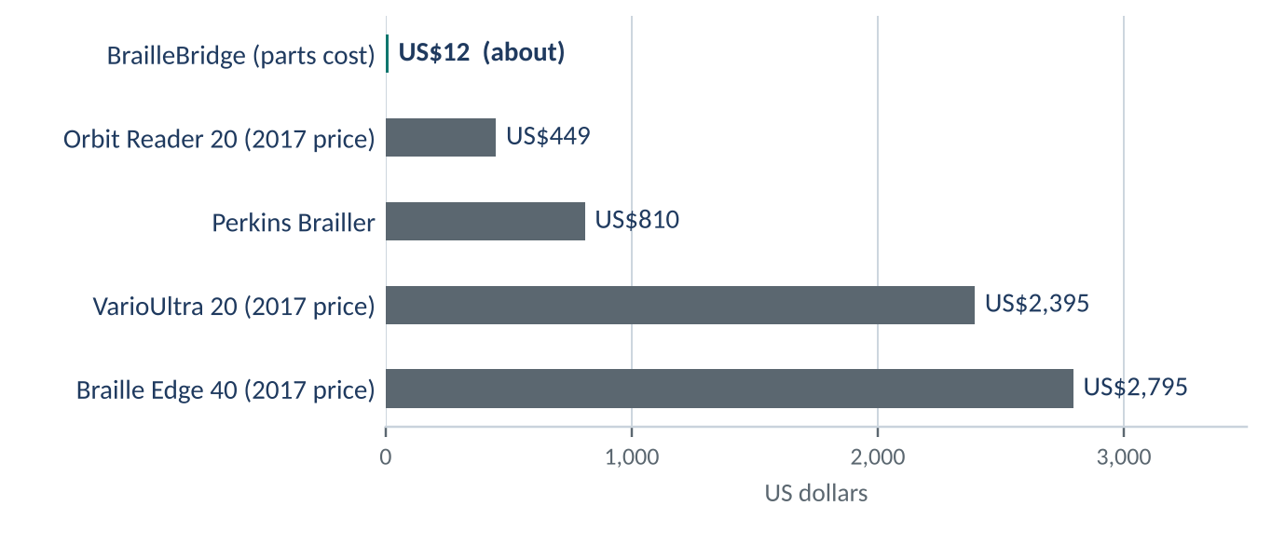
Figure 2. Indicative prices. BrailleBridge is a parts cost for the prototype; display prices are from 2017 [5, 6].
Three structural reasons explain why these alternatives fall short, even in countries with large budgets:
- They separate writing from reading. Slates and braillers let the student write but not the teacher read. Dictation and voice typing let the teacher read but take Braille away.
- Cost grows with complexity. Refreshable displays raise physical dots with precision mechanics, which keeps prices in the hundreds to thousands of dollars.
- Privacy and independence are an afterthought. Any method that relies on a second person or speech gives up confidentiality.
BrailleBridge avoids these problems by moving the complexity into software. The student's hands do the same work as on a Braille writer, and the dictionary, display and record all happen on screens that already exist.

8. How this can be life-changing
Independent writing is a prerequisite for independent learning. When a blind student can write privately and be read directly, several things change at once:
- Exams. A student can sit an examination without negotiating for a scribe, and without worrying that a rule about who may scribe will decide the day.
- Everyday school. Notes, homework and class tests no longer wait for a helper, so the student keeps pace with classmates.
- Braille skills. A device that rewards Braille writing gives students and parents a reason to keep using it. The 1996 employment gap [7] is consistent with the skill mattering, though that study does not show cause.
- Teachers' confidence. A teacher who can read the student's work immediately is more likely to include the student fully.
These are the benefits the project is designed to deliver. Pilots will measure them:
Outcome | How it will be measured in pilots
Exam independence | Share of exam answers written without a scribe, before and after
Writing speed | Characters per minute on the device compared with dictation and with the student's usual method
Teacher turnaround | Time from submission to marked paper
Accuracy | Rate of wrong or missing characters against a reference text
Cost per student | Total cost of ownership including spares and repair over a school year
Acceptance | Structured feedback from students, teachers and invigilators

9. Design principles and data handling

9.1 Principles
- Protect Braille, do not replace it. The student keeps writing with familiar six-dot chords. Translation happens after the student has written.
- Keep the data local. The Teacher Software runs in the browser with no server and no database. The class roster is stored in the browser's local storage, and exports are text files that the teacher chooses to save.
- Keep students independent. Each BrailleBridge is its own feed. One student's device never depends on another's, and a teacher can follow a whole group.
- Make it repairable and open. Every part is standard and replaceable, and the project is released under Apache 2.0 so schools and local makers can build and maintain it.
- Do not require Braille from the teacher. The teacher sees ordinary text and can mark, export and archive it like any other paper.

9.2 Questions we expect
Question | Answer
Does this replace Braille, or Braille teachers? | No. It assumes the student already writes Braille chords and adds a bridge to the teacher. Learning Braille still needs teachers and materials.
Can one teacher follow several students? | Yes. Several BrailleBridges connect to the same Teacher Software, and each appears as its own feed.
Why not simply buy a refreshable display? | Displays are mainly built for reading Braille, and even the cheapest 20-cell models cost hundreds of dollars (section 7). A class set is out of reach for most schools [6].

10. Future work and iterations in progress
BrailleBridge is under active development. The following iterations are work in progress, aimed at making typing faster, more forgiving and more comfortable:
- Autocorrect. Intelligent correction of mistyped chords and words, so a missed or extra finger does not become a wrong letter.
- Better typing on the keys. Refining how chords are read so fast, natural typing is recognised accurately.
- Faster response timings. Tuning the chord window and key handling so the device responds closer to the speed of the student's hands.
- New, creative ways of input. Exploring clever input methods beyond the basic chord, to make common letters, words and actions quicker to enter.
- An ergonomic layout. Redesigning the key layout and body so it fits the hands comfortably during long writing sessions.
- Smarter systems around the keys. Better handling of language switching, Shift, deletion and feedback.
Further planned work, from the project roadmap [8]:
- A full mathematical Braille code (fractions, brackets, powers) and wider coverage of Bangla and other Braille codes.
- Battery power with USB-C charging; audio and vibration feedback.
- Secure examination mode with student identification; PDF and DOCX export and cloud synchronisation.
- Multi-school deployment with remote grading.

11. Conclusion
The central gap is simple: a blind student can write, and a teacher can read, but the two have rarely been connected without a third person in between. BrailleBridge connects them directly. A six-key Braille keyboard, an ESP32 and a browser-based teacher console, built from replaceable parts for about US$12, turn each chord into text the teacher can read while keeping Braille as the student's natural way of writing.
In Bangladesh, the first case study, students report scarce materials, high assistive-technology costs and dependence on scribes, and a cheap, repairable, bilingual device addresses problems that exist today. Beyond Bangladesh, the same design speaks to low- and middle-income regions where vision loss is most common, and to wealthy countries where cost and Braille access remain stubborn problems. The next steps are to refine the typing experience and to take the device into classrooms.

References
[1] World Health Organization. Blindness and visual impairment (fact sheet), 10 February 2026. https://www.who.int/news-room/fact-sheets/detail/blindness-and-visual-impairment
[2] The Business Standard. Blindness rate falls by 35% in 20 years: Survey (Nationwide Blindness Survey 2020). https://www.tbsnews.net/bangladesh/blindness-rate-falls-35-20-years-survey-341074
[3] Prevalence of blindness and its determinants in Bangladeshi adult population: results from a national cross-sectional survey. https://pmc.ncbi.nlm.nih.gov/articles/PMC8977819
[4] The Business Standard. Left behind in the dark: The struggles of visually impaired students in Bangladesh. https://www.tbsnews.net/node/1124151
[5] Perkins Solutions. Perkins Brailler (product page, US$810). https://brailler.perkins.org/products/perkins-brailler
[6] National Federation of the Blind. The Orbit Reader 20: The Most Inexpensive Braille Display, October 2017. https://nfb.org/node/7598
[7] National Federation of the Blind. The Braille Literacy Crisis in America, March 2009. https://nfb.org/node/6173
[8] S. Yeasar. BrailleBridge repository, documentation and website. https://github.com/Solez-ai/braille.bridge, https://braille.mintlify.site, https://braile-bridge.vercel.app

